## Group 01

### Control Environment Monitors

Product Proposal

160005C Abeywardena K.G. 160050H Bahavan T.T.N.

160145E Ekanayake R.P. 160190K Gunawardena M.B.M. 160276F Kariyawasam U.G.S.D. 160285G Karunasena G.K.S.R. 160480B Perera W.A.H.D.

160616B Sumanthiran S. K. 160637N Tribuwan T.W.H. 160648A Uyanwatte A.M.B

Product Goals

Function: What do we need?

A product to read the temperature and the humidity inside an outdoor propagator and display on a LCD screen and store the data on a SD card on an hourly basis. Further, based on two separate thresholds, an alarm should be triggered when those thresholds are exceeded.

The product comprises of three main components:

1. Sensor Unit: A unit with humidity and temperature sensor that is battery powered and transmits the data to the Display Unit
2. Display Unit: A battery powered unit with display, removable storage, a key pad and communicating capabilities with the sensors
3. Alarm Unit: A unit with a light and a buzzer that will be triggered when the temperature and/or humidity goes beyond the corresponding thresholds

Estimated Cost

The cost of the product will be approximately 2500 including 3 sensor units, main display unit and alarming unit. The profit will be a 20% margin of this. (Selling price = LKR 3000)

Expected Volume of production

5000 products per annum for 5 years. 100 units to be produced during the initial trial period of 6 months

## Design Specifications

Performance:

1. Sensing and displaying the temperature with an accuracy around and humidity with an accuracy inside the propagator at the corresponding locations of the propagator
2. Storing the temperature and humidity data hourly during the day on a SD card that can be removed
3. Alarming the farmer when the temperature exceeds its threshold or humidity goes below the threshold to take necessary actions
4. Battery powered with the ability to operate a minimum of 1 day duration by one battery
5. Three Sensor units being enough to accurately represent the temperature and humidity distribution of the propagator

Impact from the environment

1. The sensor units should be water proofed
2. Anti-rusting
3. Should not interact with any chemicals used for the plants in the propagator as fertilizer
4. Should be able to operate at a moderate range of temperature from to



1. Damages from the farmers due to the negligence when using the sensors and Display Unit
2. RF communication between the Display Unit and the sensors should not be susceptible to the interference

Impact on the environment

1. Device is made of non-toxic materials
2. Micro particles occur from the wearing and tearing will not alter the controlled environmental factors inside the propagator
3. No poisonous by-products
4. Minimum wastage during the production

Lifetime

1. The Display Unit and the alarming unit should last a minimum of 2 years while the sensors are to last a minimum of 1 years.
2. The product should ideally last the duration of three cultivations of plants

Maintenance

1.  when the indicators displays a charge of 5%
2. Modular components. Burned out or broken parts are easily replaceable
3. Zero Day to Day maintenance
4. It should not require a maintenance for more than 2 weeks
5. One technical person who is aware about the product will be needed to maintain the product

Production Cost

1. Maximum cost per sensing unit LKR 530: Max cost of sensing units per product LKR 1650
2. Maximum cost per Display Unit LKR 750
3. Maximum cost per alarming unit LKR 100

Package, Size and Weight

1. One package will include 3 sensor units, a Display Unit and an alarming unit
   * Sensor Units: 3 x 1.5 x 2 inches 200g
   * Display Unit: 5 x 6 x 3 inches 500g
2. No packaging needed post installation

Appearance and Finish

1. Able to input the temperature and humidity thresholds manually using the key pad
2. The temperature and humidity values for each 3 points in a propagator should be displayed separately on the LCD screen
3. The battery level is indicated using few levels with three different colors of LEDs (i.e. Red 2% to 20%, Green 20% to 100%)

Types of material

1. Plastic
2. Acrylic
3. Wood

Reliability/ Accuracy

1. 6 sigma Standard failure rate 1 in a million

Safety

1. Surge Protection
2. Water proofed sensor and Display Units
3. Accurate Battery Level indicator

Installation

1. Can be installed during or after the construction of the propagator
2. Can be scaled down to smaller propagators that read values using one sensor unit only
3. Extendable even to the mass scale Green House production
4. Do not require expertise knowledge for installation
5. Installation cost is free of charge
6. Less than 1 man hours to set up the product per propagator

Operations

1. Autonomous in sensing and displaying the temperature and humidity values inside the propagator
2. Saving the logs in the main frame is manual i.e. the SD card need to be removed and read manually in the computer to save the data in the main frame
3. The LCD screen will be switched off automatically after 5 min and can be switched on using a button

Reuse

1. Modular design that makes it easily removable for use elsewhere

Disposal

1. E waste centers
2. None of the components are classified as hazardous waste

Recycling

1. 80% recyclable

How do we do it? - Conceptual Thsigns

Conceptual Design 01

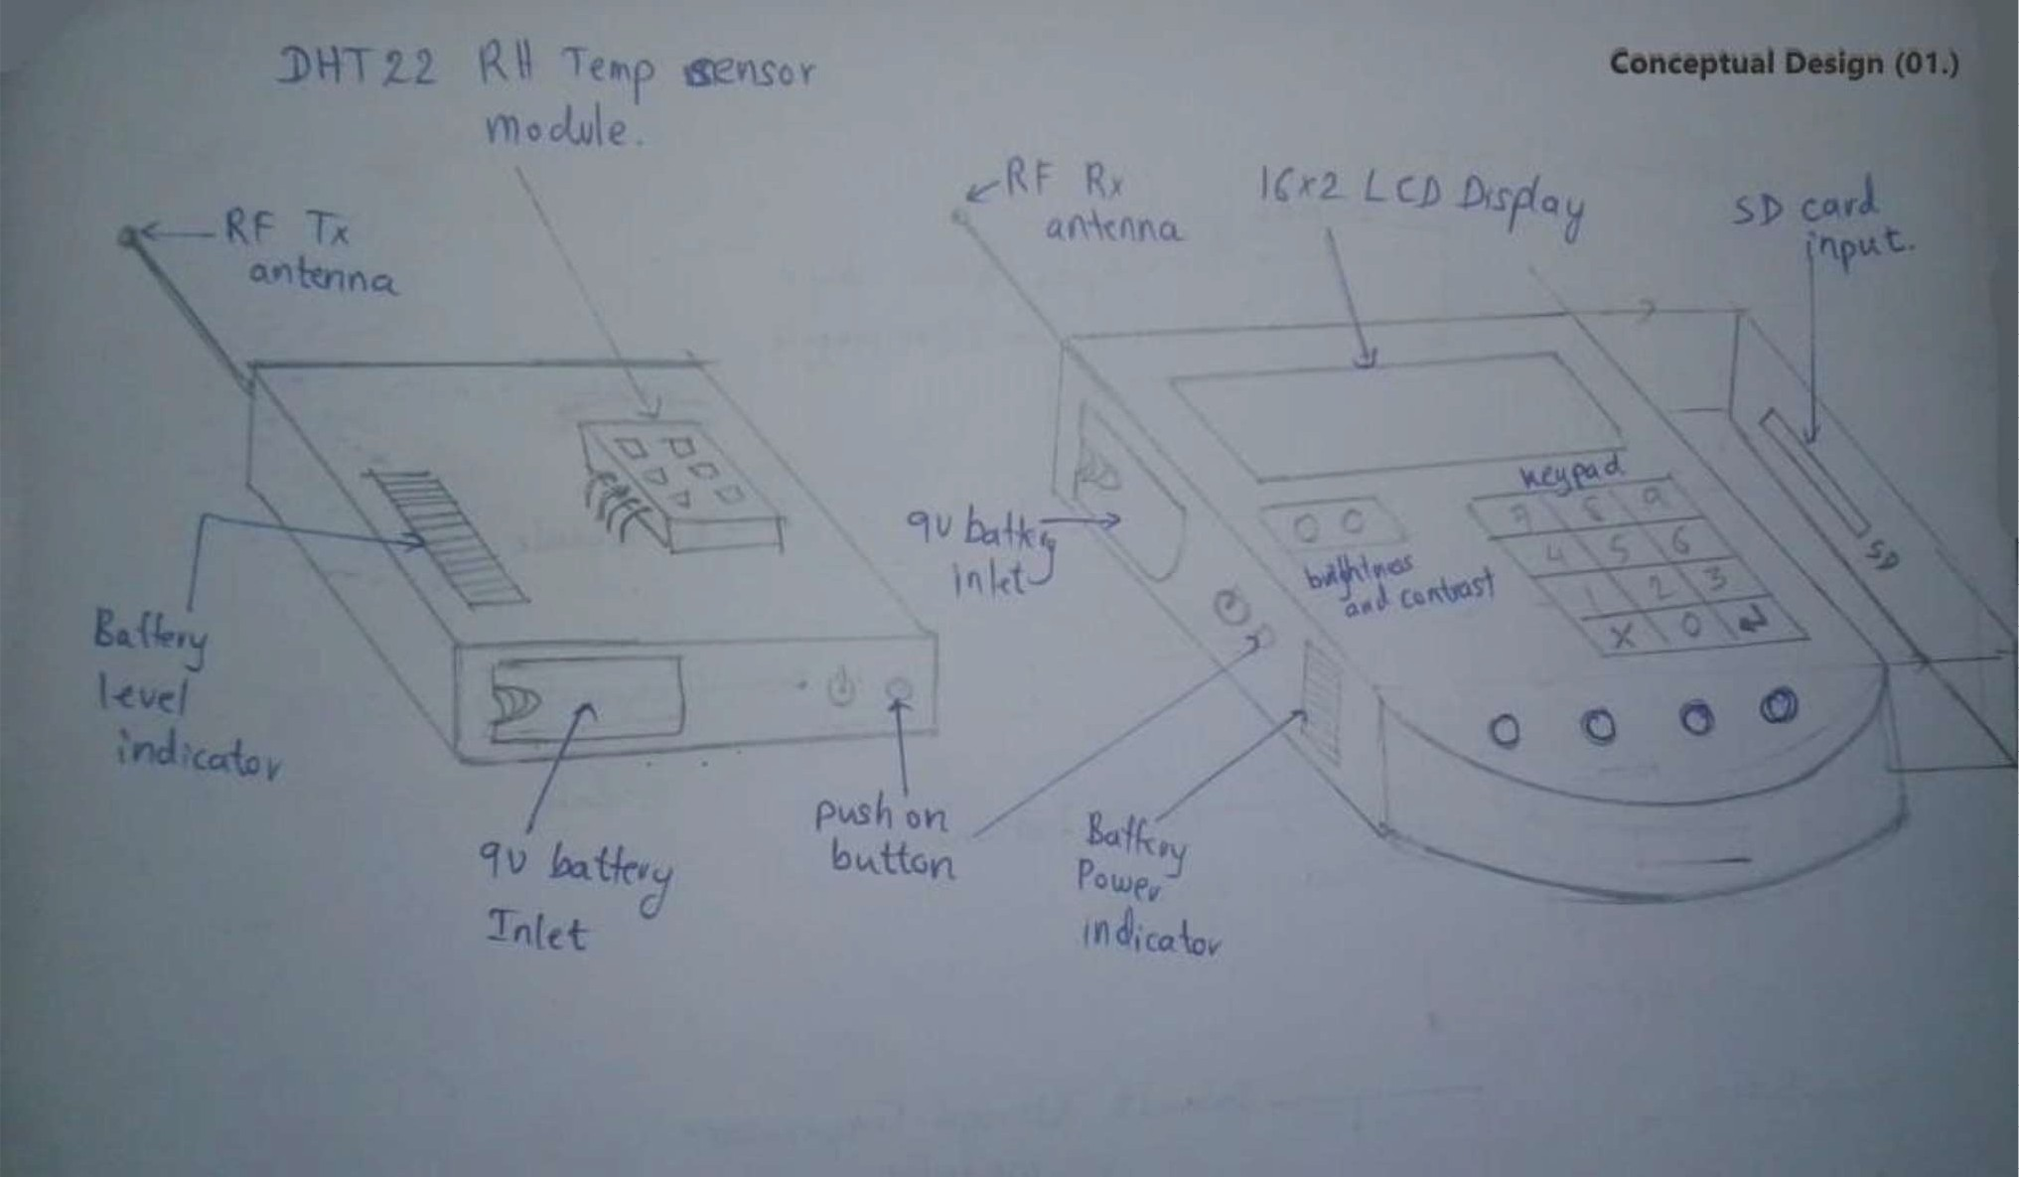

Conceptual Design 02

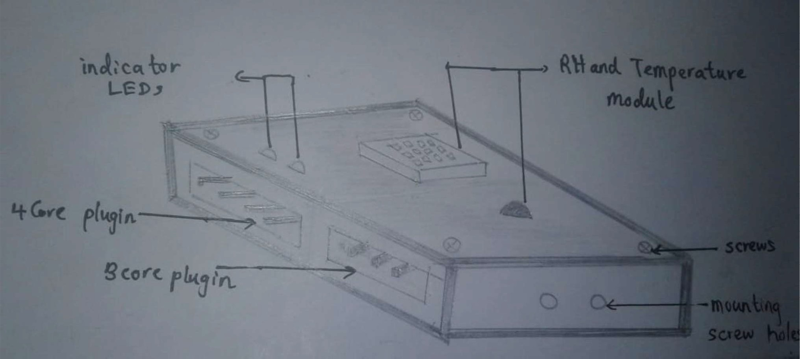

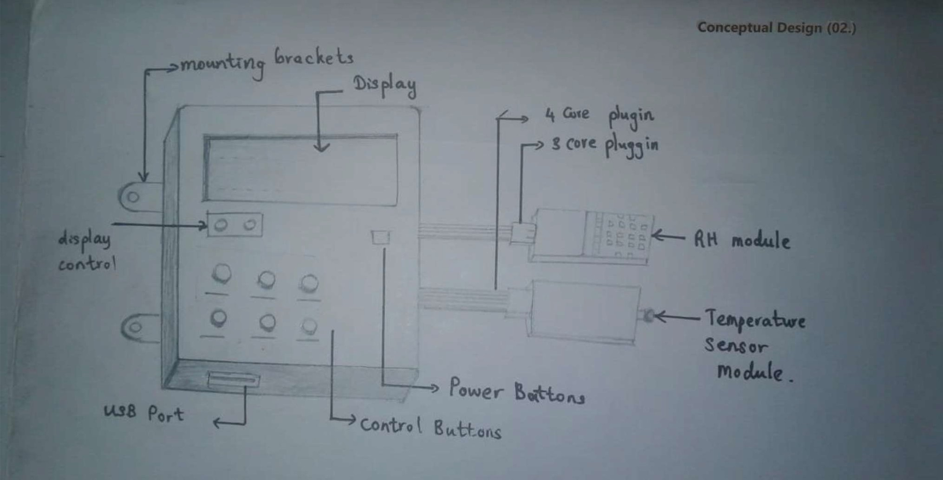

Conceptual D::sign 03

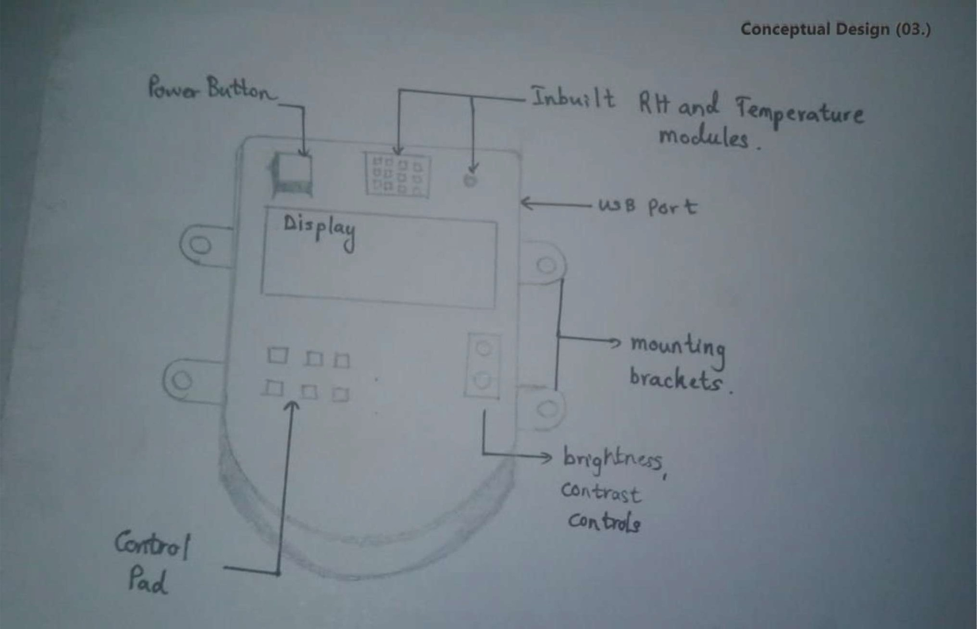

Evaluation of the conceptual designs

|  |  |  |
| --- | --- | --- |
| Conceptual Design | Advantages | Disadvantages |
| 01 | The sensor units and Display Units are portable (both are battery powered) Wireless communication hence less bulky in wiring  Can input the threshold values manually using the key pad of the Display Unit  Can detect the battery charge level using the indicator  The Display Unit can be installed further from the propagator due to wireless communication  Installation and maintenance is easy | The data can be erroneous due to certain interferences caused by other frequencies Batteries need to be replaced on a daily basis/ more bulky and expensive batteries need to used  Communication Latency can be high  If multiple propagators are located nearby, occurrence of errors can be high due to interferences |
| 02 | Wire Connections between the sensors, alarm and the display unit hence the latency is less  Less susceptible to the interferences  More accurate performance in temperature and humidity reading and displaying and alarming | Bulky as more wires need to be installed The Display Unit needs to be located very close to the propagator  External power should be given which makes the portability an issue  No SD card slot hence the computer to store the values should be closer to the propagator More electronic components (for example, a step-down transformer, rectifier) is needed as external power is being used  Costly installation |
| 03 | All in one unit Less manufacturing cost Sensor unit, Display Unit and alarm should be installed within the propagator  Can read and store the temperature and humidity values directly from the unit on to a computer using the USB cable | The damages that can occur due to the negligence of farmers can occur frequently High cost to be undertaken to safeguard them against the chemicals, water and fire  No SD card slot hence the computer to store the values should be closer to the propagator Not a modular design If a part is burnt the whole product needs to be replaced.  More electronic components (for example, a  step-down transformer, rectifier) is needed as external power is being used |

Conclusion:

Since our product is to sense the temperature and the humidity in an outdoor propagator, and that the pros outweighs the cons, we choose the Conceptual Design (01.) as our design to proceed the project.

# How do we do it? Conceptual Designs (Alarm Unit)

### Conceptual Design 01

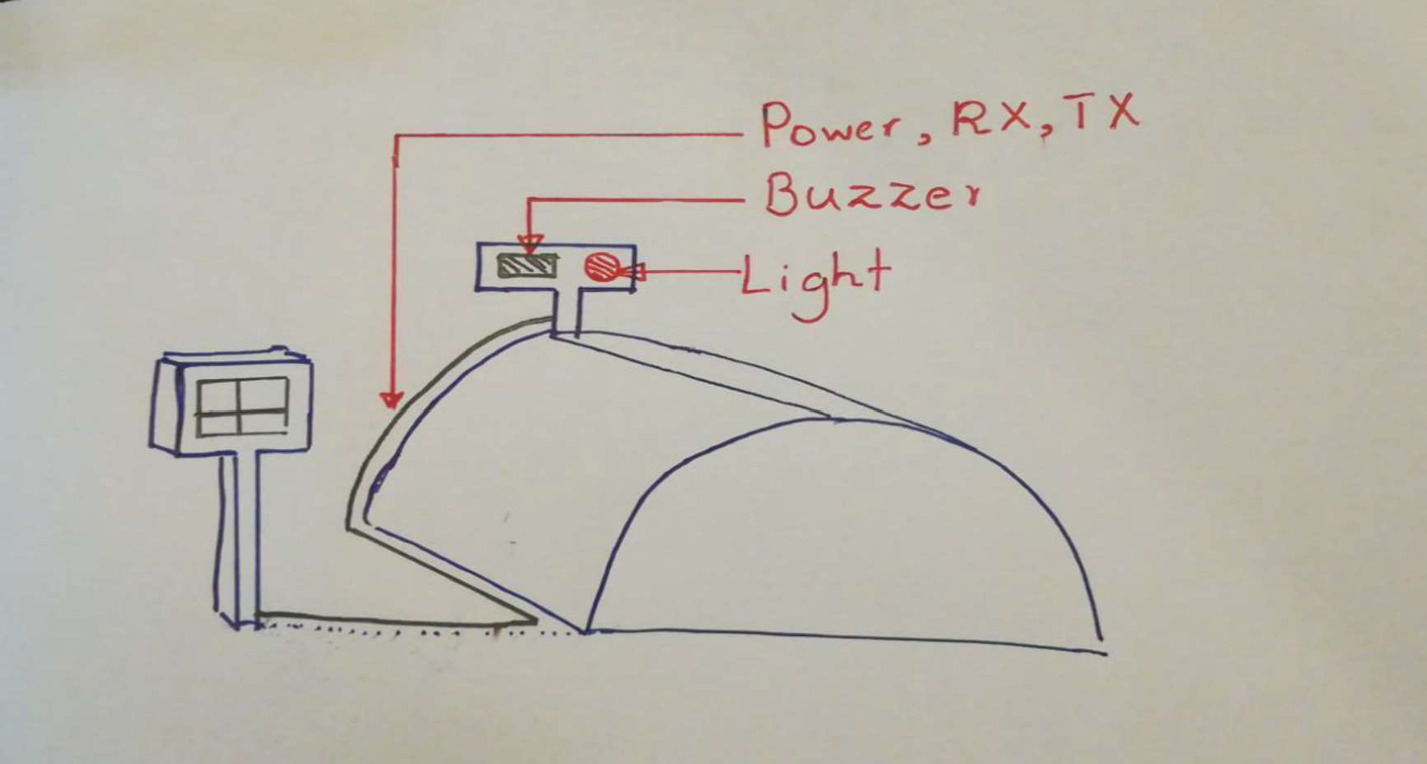

Display Unit

Alarm Unit

Propagator

Conceptual Design 02

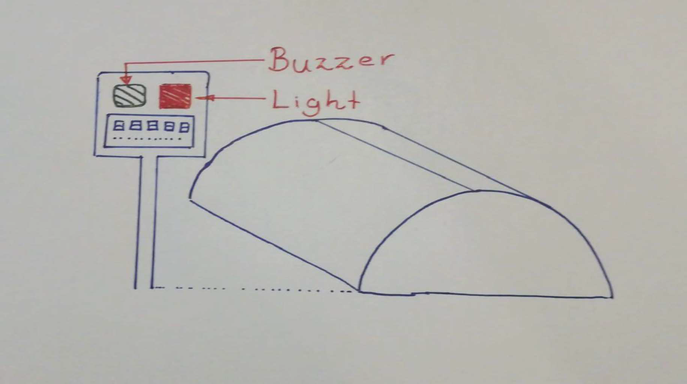

Alarm Unit

Propagator

Display Unit

Evaluation of the Conceptual designs

|  |  |  |
| --- | --- | --- |
| Conceptual  Design | Advantages | Disadvantage |
| 01 | The alarm and the light is installed near the respective propagator  Separate Alarm Unit hence any modification to alarm unit can be made separately | Need to power up the alarm unit either using separate battery or from the display unit power Need the wires to connect the two units hence bulky  Damages are possible as the alarm unit is installed near the propagator |
| 02 | Alarm Unit is installed inside the display unit hence powering the alarm unit is  convenient  Less wires (or no wires) needed to connect the microcontroller output to the buzzer and light  Easy installation  Can identify the region where the temperature and the humidity exceeds the thresholds as display unit and alarm unit is at the same place | Battery can drain much quicker than the design (01.)  Modular designing is not achieved modifications to the alarm unit cannot be separately done |

Conclusion:

Since it is not feasible to have wires drawn between the display unit and alarm unit and that the farmers need to identify where the corresponding region is the conceptual design (02.) is chosen. Hence the Alarming unit will be embedded in the display unit chosen in the previous section and the buzzer and the light will be powered using the same 9V rechargeable battery used in display unit.

How do we do it? Flow Charts (For one product)

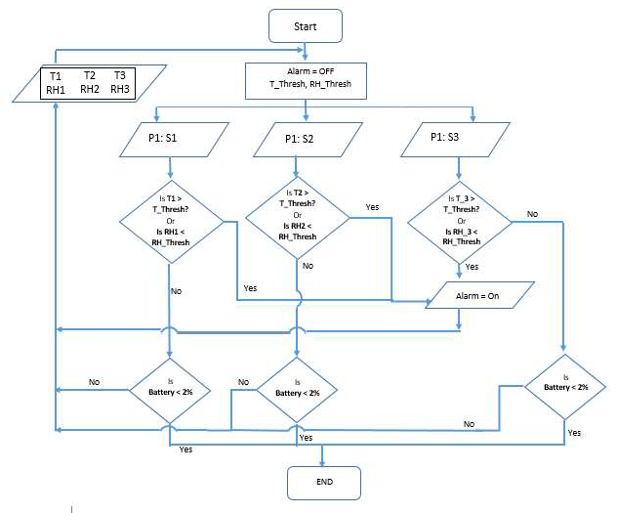Flow Chart 01

Flow Chart 02

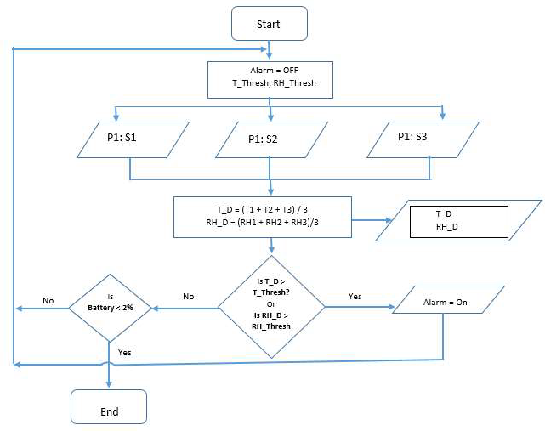

Evaluation of the Flow Charts

|  |  |  |
| --- | --- | --- |
| Flow  Chart | Advantages | Disadvantages |
| 01 | Considers the temperature and the humidity at each point of the propagator ( from 3 sensors installed)  Better accuracy in detecting the temperature and humidity exceeding the thresholds Display showing the temperature and humidity for each sensor in the propagator | Logics should be evaluated for each sensor in the propagator hence computationally heavy |
| 02 | Computationally easy  A single value represents the temperature and the humidity of the propagator | The alarm get triggered when the average exceeds the threshold For longer propagators, assuming the temperature and humidity distribution is uniform might be erroneous  2 of the sensors are redundant this type of algorithm can be run using one sensor  Less Accurate |

Conclusion:

Based on the information gathered from the interpreter, it would be great if we can read and display the temperature and humidity at three different points in the propagator. This helps the farmer to locate the region at which the temperature has risen above the threshold and rectify it at that region. Hence the most appropriate flow chart is the Flow Chart 01.

Apart from the main functionality, the product will sample the temperature and humidity values at each points hourly and store it in a SD card for further purposes.